**Project Proposal: AgriSense - A-Real-Time-Smart-Farming-Platform-for-Plant-Health-Monitoring**

**1. Executive Summary**

AgriSense is an innovative smart farming solution designed to revolutionize strawberry cultivation through the synergistic integration of Artificial Intelligence (AI), Internet of Things (IoT), and mobile technology. This project addresses critical challenges in traditional agriculture, such as inefficient resource management, delayed disease detection, and labor-intensive practices. By leveraging real-time environmental monitoring, AI-powered disease diagnostics (YOLO V11 instance segmentation), and automated control systems, AgriSense aims to optimize crop health, enhance resource efficiency, and significantly improve yield. The user-friendly mobile application provides farmers with actionable insights and seamless control, making advanced agricultural technology accessible and impactful.

**2. Introduction/Background**

The global demand for sustainable and efficient agricultural practices is growing rapidly. Traditional farming methods often struggle with unpredictable environmental factors, the laborious process of manual inspection, and the reactive nature of disease management. These inefficiencies lead to substantial crop losses, increased operational costs, and environmental strain due particularly to excessive water and fertilizer use. Our project seeks to bridge this gap by introducing a smart, data-driven approach that empowers farmers with precise control and predictive capabilities, starting with the cultivation of strawberries, a high-value and sensitive crop.

**3. Problem Statement**

* **Inefficient Resource Utilization:** Manual or time-based irrigation and fertilization lead to over- or under-watering, wasting precious resources and potentially harming crops.
* **Delayed Disease Detection:** Visual inspection by humans is often too late for effective intervention, leading to widespread disease and significant crop loss.
* **Lack of Real-time Insights:** Farmers often lack immediate access to critical environmental data and plant health status, hindering proactive decision-making.
* **Labor-Intensive Operations:** Many farming tasks remain manual, increasing operational costs and reducing scalability.

**4. Project Objectives**

The primary objectives of the AgriSense project are to:

* **Automate Environmental Monitoring:** Continuously collect and transmit real-time soil moisture, temperature, and humidity data using IoT sensors.
* **Implement Intelligent Irrigation:** Develop an automated system to precisely control water pumps based on real-time soil moisture readings, optimizing water usage.
* **Enable AI-Powered Disease Detection:** Integrate a YOLO V11 instance segmentation model to accurately identify and localize strawberry plant diseases from captured images at an early stage.
* **Provide Remote Control & Monitoring:** Develop a user-friendly mobile application for farmers to access real-time data, receive alerts, and control system parameters remotely.
* **Ensure Data-Driven Decision Making:** Establish a robust backend system for storing, processing, and analyzing sensor data and AI insights to provide actionable recommendations.
* **Enhance Operational Efficiency:** Reduce manual labor and resource waste through automation and intelligent system responses.

**5. Proposed Solution / Project Methodology**

AgriSense is built upon a layered architecture that integrates hardware, software, and artificial intelligence to create a comprehensive smart farming ecosystem.

**5.1. System Architecture**

The system comprises four main layers: IoT, Backend, AI, and Mobile App, interacting as follows:

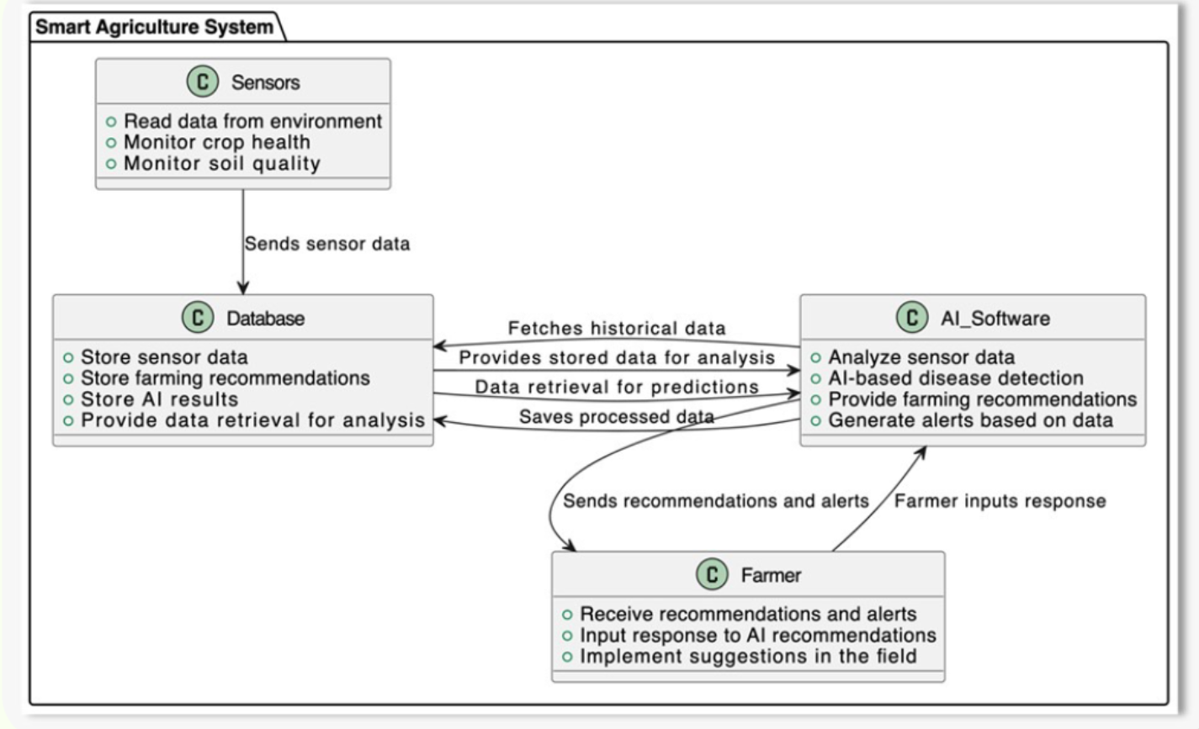

**5.2. Hardware Components**

The physical layer of AgriSense is built using reliable and cost-effective components:

* **ESP32 Microcontroller:** The central processing unit for sensor data acquisition, local logic execution (e.g., water pump control based on soil moisture), and communication with the backend.
* **ESP32-CAM Module:** Integrates camera capabilities for capturing high-resolution images of plants, crucial for AI-driven disease detection, and controls the stepper motor for precise camera positioning.
* **FTDI (BLANCGROUP USB Adapter Board (FT232RL)):** Facilitates programming and serial communication with the ESP32 modules.
* **NEMA 17 Stepper Stepping Motor & A4988 Stepper Motor Driver:** Provides precise, controlled linear or rotational movement for automated tasks (e.g., camera scanning).
* **GT2 Timing Pulleys & Belt, V-Slot Linear Rails & Gantry Plates, Plastic Wheels:** Form the mechanical framework for smooth and accurate linear motion systems.
* **3x Water Pumps & L298N Dual H-Bridge Motor Driver:** Enable automated and controlled irrigation based on sensor data.
* **12V Power Supply & Power Converter to 5V:** Provide stable and appropriate power levels for all system components.
* **DHT11 Temperature and Humidity Sensor:** Monitors ambient environmental conditions critical for plant health.
* **Soil Moisture Sensors (3 units):** Provide real-time data on soil hydration levels to trigger irrigation.

**5.3. Software Components**

The intelligence of AgriSense is powered by a robust software stack:

* **Microcontroller Firmware (C++/Arduino):** Custom code running on ESP32 boards to manage sensor readings, control actuators, handle local automation logic (e.g., pump activation), and manage Wi-Fi communication with the backend.
* **Backend (.NET Core, C#):** A powerful backend system responsible for:
  + Receiving and storing sensor data and images from IoT devices.
  + Managing data flow to and from the AI model.
  + Storing AI analysis results and historical data in a cloud database.
  + Serving real-time and historical data, as well as alerts, to the mobile application.
  + Sending specific control parameters (e.g., image taking time) to the ESP32-CAM.
* **AI Model (YOLO V11 Instance Segmentation):** Integrated with the backend, this model processes captured images to accurately identify and segment diseased areas on strawberry leaves, providing precise diagnostic information.
* **Mobile Application (Platform/Framework TBD):** The user-facing interface, connecting to the .NET backend to:
  + Display real-time sensor data and system status.
  + Present disease detection results and historical trends.
  + Provide alerts and notifications.
  + Allow users to configure system parameters and trigger certain actions (e.g., request new image capture).
* **Database (Type TBD, Cloud-based):** Used by the .NET backend to store all sensor readings, images, AI analysis results, and system configurations.

**5.4. Data Flow**

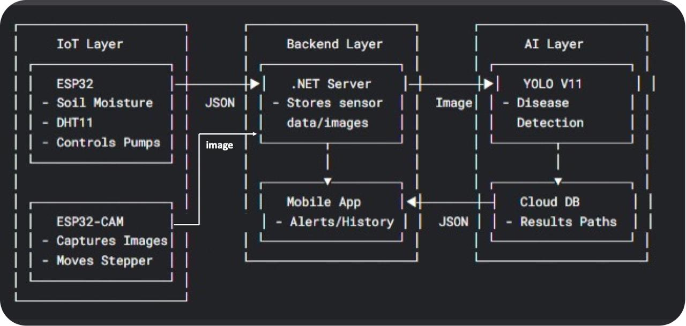

**6. Innovation and Novelty**

AgriSense distinguishes itself from conventional smart farming solutions through several key innovative aspects:

* **Precision AI Diagnostics:** Unlike systems relying on simple image classification or manual checks, our integration of YOLO V11 instance segmentation provides highly accurate, pixel-level identification of diseases, enabling earlier and more targeted interventions.
* **Seamless Cross-Platform Integration:** The project uniquely combines robust IoT hardware with a powerful .NET backend and a user-centric mobile application, creating a truly integrated ecosystem for comprehensive farm management.
* **Decentralized IoT Logic:** By embedding most of the critical IoT control logic directly onto the ESP32 microcontrollers, the system ensures real-time responsiveness for tasks like irrigation, even with intermittent backend connectivity, enhancing reliability.
* **Actionable Insights for Farmers:** The mobile interface transforms raw data and complex AI analysis into easily understandable insights and actionable alerts, empowering farmers to make informed decisions without needing deep technical expertise.

**7. Expected Outcomes and Benefits**

The successful implementation of AgriSense is expected to yield significant benefits:

* **Increased Resource Efficiency:** Optimized water usage through intelligent irrigation, reducing waste and operational costs.
* **Enhanced Crop Health & Yield:** Early and accurate disease detection enables timely intervention, minimizing crop loss and maximizing yield potential.
* **Reduced Labor Requirements:** Automation of monitoring and irrigation tasks frees up manual labor for other critical farming activities.
* **Improved Decision-Making:** Real-time data and AI-driven insights empower farmers with the information needed for proactive and effective crop management.
* **Scalability & Adaptability:** The modular architecture allows for future expansion to include more sensors, different crops, and additional automation features.
* **Environmental Sustainability:** By optimizing resource use and preventing disease spread, the system contributes to more sustainable agricultural practices.

**8. Project Scope**

**In-Scope:**

* Development of IoT hardware for soil moisture, temperature/humidity sensing, and water pump/stepper motor control.
* Integration of ESP32-CAM for image capture.
* Development of a .NET backend for data aggregation, storage, and AI model integration.
* Integration and fine-tuning of YOLO V11 for strawberry disease instance segmentation.
* Development of a mobile application for data visualization, alerts, and basic system control.
* Proof-of-concept deployment and testing in a controlled environment (e.g., small greenhouse/farm plot).

**Out-of-Scope (for initial phase):**

* Large-scale commercial deployment.
* Integration with external weather APIs or market data.
* Automated nutrient delivery systems (though the stepper motor could be adapted for this in future).
* Detection of pests or other non-disease plant issues (beyond the scope of YOLO V11 for diseases).
* Advanced predictive analytics for yield forecasting.

**9. Timeline/Phases (General)**

* **Phase 1: Research & Design (Completed)**
  + Detailed system architecture and component selection.
  + Schematic design and initial prototyping.
* **Phase 2: Hardware & Firmware Development**
  + Assembly and testing of IoT modules (ESP32, sensors, actuators).
  + Development of robust ESP32 firmware for data acquisition and control.
* **Phase 3: Backend & AI Integration**
  + Development of .NET backend services and database integration.
  + Training/Fine-tuning and integration of YOLO V11 model.
* **Phase 4: Mobile Application Development**
  + Design and development of the user interface and core functionalities.
  + Integration with backend APIs.
* **Phase 5: System Integration & Testing**
  + End-to-end testing of all layers.
  + Performance evaluation and debugging.
  + Pilot deployment in a controlled environment.
* **Phase 6: Documentation & Presentation**
  + Finalizing project documentation, reports, and presentation materials.

**10. Team Overview**

The project is led by **Ibrahim Al Banawy** and developed under the umbrella of **Agri Lens**. The team combines expertise in IoT hardware, software development, artificial intelligence, and mobile application design, ensuring a multidisciplinary approach to project execution.

**11. Conclusion**

AgriSense represents a significant step forward in applying cutting-edge technology to address real-world agricultural challenges. By providing an intelligent, automated, and user-friendly system for strawberry cultivation, we aim to contribute to more efficient, sustainable, and productive farming practices. We are confident that this project has the potential to deliver substantial benefits to farmers and the agricultural industry as a whole.